1. Square Wave:

>> t = 0:0.2:10;

>> y = 1.25/2\*(square(0.4\*pi\*t,40)+1);

>> plot(t,y)

>> xlabel('time(s)');

>> ylabel('Amplitude');

>> title('Square Wave')

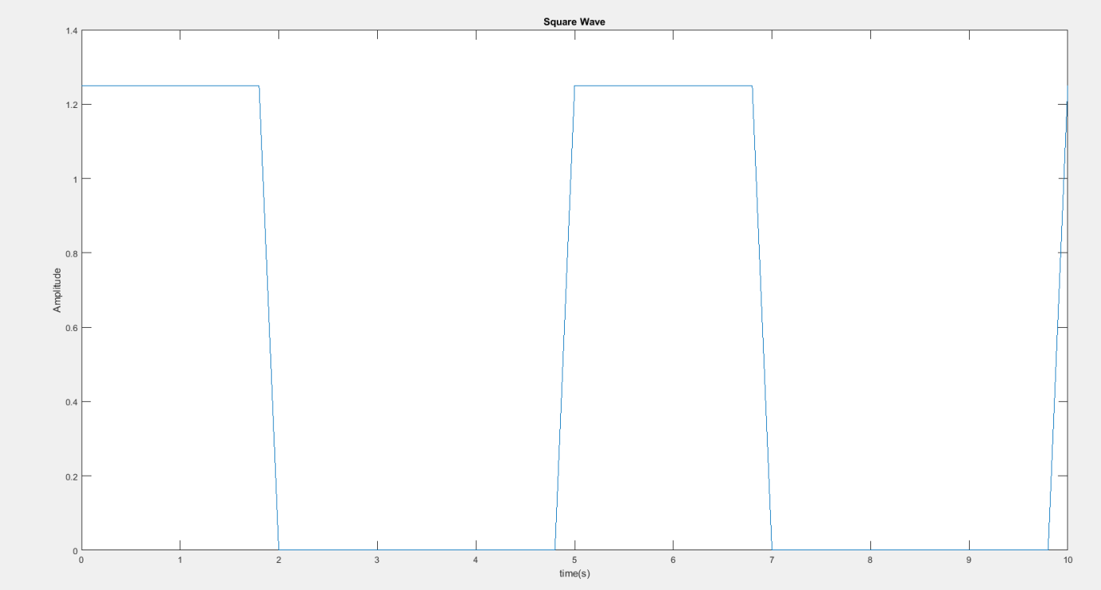

Triangular:

>> t = 0:.2:10;

>> y = sawtooth(2\*pi\*.2\*t,.5);

>> y = y +1;

>> y = y\*4;

>> plot(t,y)

>> xlabel('time(s)');

>> ylabel('Amplitude');

>> title('Triangular Wave')

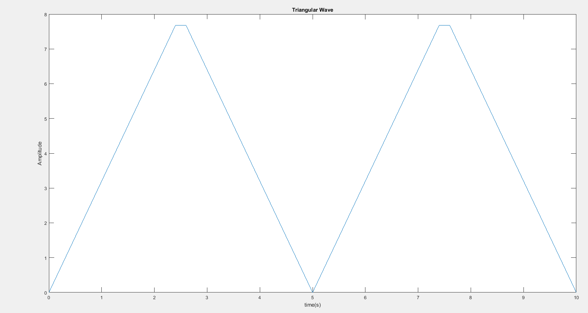

Sawtooth:

>> t = 0:.2:10;

>> y = -3\*(sawtooth(2\*pi\*.2\*t) + 1);

>> plot(t,y)

>> xlabel('time(s)');

>> ylabel('Amplitude');

>> title('Sawtooth Wave')

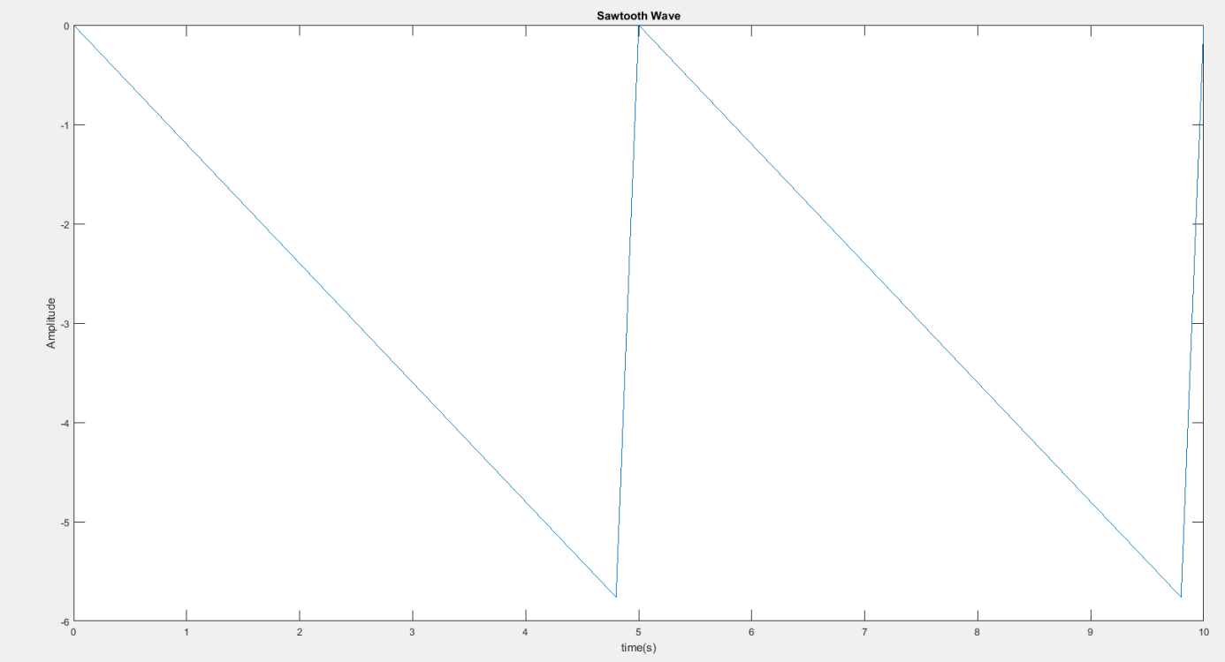

Half-rectified Sine:

function [ x ] = rectSine( t)

x = max(0, sin(t));

end

>> t = 0:0.2:10;

>> y = rectSine(2\*pi\*.2\*t);

>> y = y\*12.5;

>> plot(t,y)

>> xlabel('time(s)');

>> ylabel('Amplitude');

>> title('Half-Rectified Sine Wave')

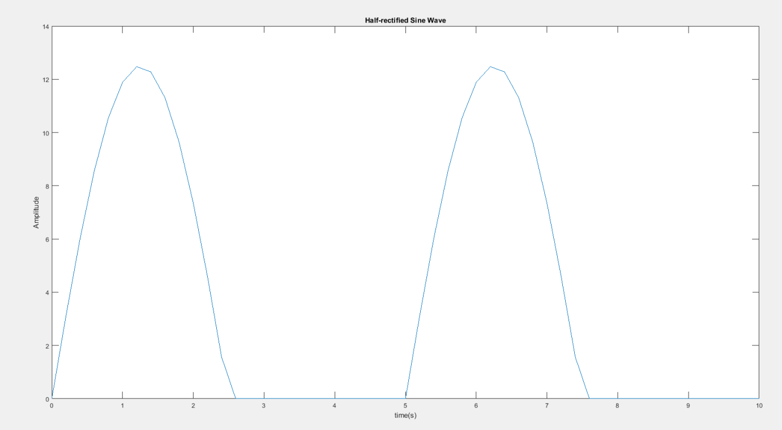

b)Square Wave:

ao= 0.5

ak= = = =

Triangular Wave:

ao= 4

ak=

Sawtooth Wave:

ao= -3

ak=

Half-rectified Sine Wave:

ao= 2.5

ak= u = sint du= costdt dv= $e^{-2jπkt/5}dt$ v = $\frac{{5e}^{-2jπkt/5}}{-2πjk}$

= $\frac{sint*{5e}^{-2jπkt/5}}{-2πjk}-\int_{0}^{5/2}{\frac{{5e}^{-2jπkt/5}}{-2πjk}*costdt}$ u = cost du= -sint.dt v = $e^{-2jπkt/5}$ dv = $\frac{{5e}^{-2jπkt/5}}{-2πjk}$

$e^{-2jπkt/5} cost$ + $\int_{0}^{5/2}{e^{-2jπkt/5}sintdt}$

= $\frac{sint*{5e}^{-2jπkt/5}}{-2πjk}-\frac{{5e}^{-\frac{2jπkt}{5}}}{-2πjk}*cost-\int_{0}^{\frac{5}{2}}{\frac{{5e}^{-\frac{2jπkt}{5}}}{-2πjk}*sintdt}+ \int_{0}^{5/2}{\frac{{5e}^{-2jπkt/5}}{-2πjk}*sintdt}$

= $(sint-cost)\frac{{5e}^{-2jπkt/5}}{-2πjk}$

c)

Square Wave:

function [ sum ] = sumSquare( t,x )

n = -x;

sum = 0;

j = sqrt(-1);

e = exp(1);

while n < 0

sum = sum + ((5-5\*power(e,(- 4/5)\*pi\*j\*n)))/(8\*pi\*j\*n)\*(power(e,2\*pi\*n\*(1/5)\*t));

n = n + 1;

end

n = n + 1;

while n < x

sum = sum + ((5-5\*power(e,(-4/5)\*pi\*j\*n)))/(8\*pi\*j\*n)\*(power(e,2\*pi\*n\*(1/5)\*t));

n = n + 1;

end

end

Triangular Wave:

function [ sum ] = sumTriangular( t,x )

n = -x;

sum = 0;

j = sqrt(-1);

e = exp(1);

while n < 0

sum = sum + (-4\*((pi\*j\*n)+1))\*(power(e,-1\*pi\*j\*n)+power(e,pi\*j\*n))/(power(pi\*j\*n,2))\*(power(e,2\*pi\*n\*(1/5)\*t));

n = n + 1;

end

n = n + 1;

while n < x

sum = sum + (-4\*((pi\*j\*n)+1))\*(power(e,-1\*pi\*j\*n)+power(e,pi\*j\*n))/(power(pi\*j\*n,2))\*(power(e,2\*pi\*n\*(1/5)\*t));

n = n + 1;

end

end

Sawtooth Wave:

function [ sum ] = sumSawtooth( t,x )

n = -x;

sum = 0;

j = sqrt(-1);

e = exp(1);

while n <= 0

sum = sum + 25\*((-2\*pi\*j\*t -1))/(power(2\*pi\*j\*t,2))\*(power(e,2\*pi\*n\*(1/5)\*t));

n = n + 1;

end

while n < x

sum = sum + 25\*((-2\*pi\*j\*t -1))/(power(2\*pi\*j\*t,2))\*power(e,2\*pi\*n\*(1/5)\*t);

n = n + 1;

end

end

Half-Rectified Sine Wave:

function [ sum ] = sumRectifiedSinus( t,x )

a0 = 2.5;

n = -x;

sum = 0;

j = sqrt(-1);

e = exp(1);

while n < 0

sum = sum + ((5\*power(e,-2\*pi\*j\*t\*n))/(-2\*pi\*j\*n)\*(sint-cost))/2 \*(power(e,2\*pi\*n\*(1/5)\*t));

n = n + 1;

end

sum = sum + a0\*(power(e,2\*pi\*n\*(1/5)\*t));

n = n + 1;

while n < x

sum = sum + ((5\*power(e,-2\*pi\*j\*t\*n))/(-2\*pi\*j\*n)\*(sint-cost))/2 \*(power(e,2\*pi\*n\*(1/5)\*t))

n = n + 1;

end